AI-Driven Customer Analytics : Data Mining Based Behaviour (EMOTION INTELLIGENCE : APERSONALIZED RECOMMANDATION SYSTEM USIG FACIAL AND VOCAL CUES)
INDEX
- INTRODUCTION
  - Purpose
  - Scope
  - Model Diagrams
  - Overview
- Literature survey
- System Analysis
  - Existing System & Disadvantages
  - Problem Statement
  - Proposed System & Advantages
- System Requirements Specification
  - Functional Requirements
  - Non-Functional Requirements.
  - Hardware Requirements
  - Software Requirements
- System design
  - System Specifications
  - System Components (Modules)
  - UML/DFD's
- Implementation
  - Sample Code
- System Testing
  - Types of Testing
  - Test Cases
  - Discussion of Results (Screen Shots)
- Conclusion and Future Enhancements
  - Conclusion
  - Future Enhancements
- References

AI-Driven Customer Analytics : Data Mining Based Behaviour (EMOTION INTELLIGENCE : APERSONALIZED RECOMMANDATION SYSTEM USIG FACIAL AND VOCAL CUES)

Abstract

As organizations advance in their digital transformation journey, examining customer behavior has become a vital aspect of improving the customer experience and business success. This paper presents an AI-enabled customer analytics system based on data mining and emotion intelligence that makes individualized recommendations based on customers' facial and vocal expressions. It consists of three modules: the Facial Emotion Recognition Module, which assesses customers' emotional state by reviewing their facial expressions in real-time; the Voice Tone Analysis Module, which interprets gathered linguistic features to derive sentiment and engagement; and the Personalized Recommendation Module which utilizes the contextualized customer data regarding both emotional and behavioral data to generate personalized recommendations of products or services that are most relevant to the customer. More specifically, this multimodal emotion recognition,a combination of emotion-aware AI and data analytics, results in not only personalization but also enhanced comprehension and responses to customer needs, resulting in improved engagement, satisfaction and decision-making. Overall, the findings of this paper demonstrate the possibilities for emotion-aware AI utilization to develop customer interaction platforms that have greater empathy and user-focus.

1.Introduction

In the current competitive marketplace, organizations are more and more reliant upon customer behavior to deliver customized services and enhance user experience. Conventional analytics strategies tend to be based on transactional data, purchase history, or clickstream analysis, which only give a partial view of the emotional and psychological mindset of the customer. Emotions, though, are responsible for decision-making, preference, satisfaction, and loyalty. By incorporating emotion intelligence into analytics, companies can better understand their customers' needs and provide more personalized and relevant recommendations.

Recent breakthroughs in artificial intelligence (AI), computer vision, and speech processing allow the processing of multimodal signals like facial expressions and voice cues to infer emotions in real-time. Facial emotion recognition identifies minute changes in the facial muscles to categorize emotions like happiness, anger, sadness, or surprise, whereas voice tone analysis assesses pitch, tone, and speech rhythm variations to establish the mood or engagement level of the speaker. These technologies, when integrated with advanced data mining solutions, help businesses shift away from generalized recommendation systems towards highly personalized, emotion-sensing customer experiences.

The system integrates all these AI-based approaches into an umbrella framework. The Facial Emotion Recognition Module takes in and analyzes facial expressions of the customer, while the Voice Tone Analysis Module gives complementary information from audio signals. These emotional facts are then passed to the Personalized Recommendation Module, where high-tech data mining and machine learning algorithms are used to correlate the products or services with the customer's current emotion and preferences. Such a multimodal, affect-sensitive approach not only improves personalization but enables companies to respond ahead of customer satisfaction and engagement trends.

As a whole, this AI-based customer analytics platform reveals the promise of marrying emotion intelligence with data-driven recommendation platforms. Utilizing facial and vocal expressions, companies can build highly sensitive and empathetic interactions, ultimately leading to more meaningful customer relationships, better decision-making, and business growth.

  - Purpuse

This research aims to create and construct an emotionally intelligent AI customer analytics system that develops emotional intelligence to identify and adapt to consumers in a more personalized and human-centered manner. Traditional recommendation systems rely on data that normally lies solely on historical preference data such as purchase history, browsing behavior, or demographic data. Even though stores tried for more personalization, customers are still broadly categorized based on historical data, missing out on their emotional dynamic that contributes to personal decision-making and satisfaction. The proposed system aims to enhance this dynamic by implementing sophisticated AI to analyze both facial expressions and vocal tone with the goal of achieving a multimodal understanding of the customer in that moment. The Facial Emotion Recognition Module is used to identify subtle movements in the customers facial expression to assess their emotional state as happy, surprised, angry, or sad using the technology available. The Voice Tone Analysis Module examines light and darkness of the customers voice and inflection in their phrasing to establish overall mood and engagement. By combining both models, the Personalized Recommendation Module will aid the consumers by providing timely and relevant information that takes into account not only their preselected historical preferences but their emotional dynamic as it relates to that moment. The system's primary objective is to foster customer experience, increase engagement, and build loyalty, through the creation of an emotional, intelligent, and responsive platform. Further, it showcases the possibilities of marrying emotion-aware AI and data mining approaches to business analytics in a new approach to understand customer behaviour, and provide organizations with a more informed and strategic base for decision making.

1.2 Scope
The project scope is to create a customer analytics system powered by AI that uses emotion intelligence to provide real-time personalized recommendations based on facial and vocal expressions. The system is to be used in various customer-facing industries like e-commerce, retail, banking, hospitality, and digital content sites, where knowing the customer behavior and emotions can help maximize user interaction and satisfaction. In this scope, the Facial Emotion Recognition Module is engaged in detecting and analyzing visual signals to detect a variety of emotions, while the Voice Tone Analysis Module deciphers auditory signals to deduce sentiment and engagement levels. These findings are then used as input for the Personalized Recommendation Module, which produces adaptive recommendations that are congruent with the customer's emotional state as well as behavioral patterns. The system also prioritizes real-time processing so that the recommendations are timely and context-sensitive, enhancing responsiveness and customer experience. Additionally, the project incorporates data collection, preprocessing, feature extraction, and the use of advanced machine learning and data mining techniques to guarantee correct emotion recognition and recommendation accuracy. The scope does not include physical interactions or surroundings outside the digital interfaces but provides a solid ground for embedding multimodal emotion-aware AI on customer interaction platforms in the future. Overall, the system seeks to develop empathetic, intelligent, and personalized experiences to help businesses get to know their customers better, increase engagement, and accelerate strategic growth.

1.3 Model Diagrams:
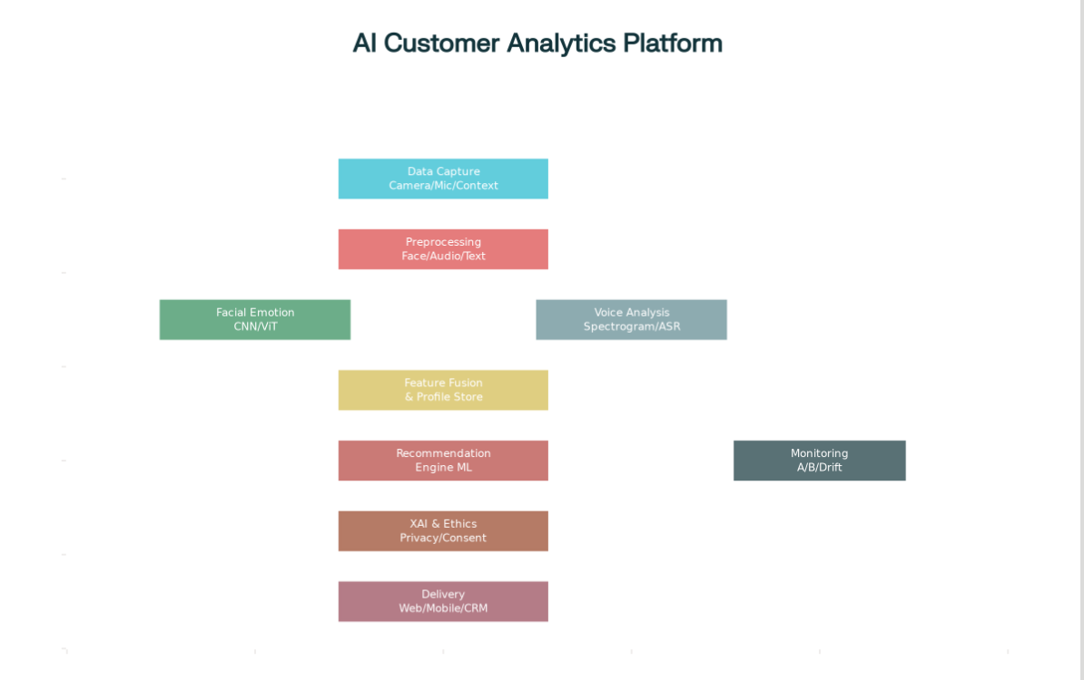

1.4 Overview
The objective of the specified project is to develop a customer analytics system that draws on artificial intelligence and incorporates emotion intelligence to deliver personalized recommendations based on facial and voice signals. Conventional analytics and recommendation systems employ historical behavior of the user, such as previous purchases, browsing or search history, or demographic information; however, none of these signals include the current emotional or psychological state of the user to facilitate/disrupt real-time decision making. To address this issue, the analytics system will have three primary modules: the Facial Emotion Recognition Module, which will detect emotional and psychological states based on facial expressions (e.g., happiness, sadness, anger, or surprise); the Voice Tone Analysis Module, which will analyze vocal cues such as pitch, tone, and intensity to determine sentiment and engagement; and lastly, the Personalized Recommendation Module, which will aggregate the outputs from the Face Emotion Recognition Module and the Voice Tone Analysis Module with advanced data mining and machine-learning capabilities to facilitate contextualized, individualized recommendations.
The real-time functionality of the system ensures that recommendations are based on the customer's present emotional and behavioral state. By integrating multi-modal emotion recognition with predictive analytics, this platform does not only improve personalization, but also allows businesses to respond to customer needs more proactively, ensure greater satisfaction, and increase loyalty. The project consists of a whole range of efforts including data collection, preprocessing, feature extraction, and employment of AI models for detecting emotions and generating recommendations. Overall this system represents a notable advancement in emotion-detecting, intelligent, customer interaction platforms and shows the potential for the combination of AI, data mining, and emotion analysis to enhance customer engagement practices in a more empathetic and effective manner.

2.Litrature Survay:-

1. AI-Based Facial Emotion Analysis for Customer Emotion Detection—An Explatory Research

Abstract:
This research discusses the potential of artificial intelligence in facial expression analysis to detect customer emotions. It discusses several AI methods and their efficiency in reading facial signals to gauge customer sentiments. The study emphasizes the potential of AI-based facial emotion analysis to improve customer experience through greater emotional response insights.

2. Facial Expression and Voice Recognition of Emotions: Review and Analysis

Abstract:
The paper is a review and comparison of 15 facial expression techniques and 17 voice techniques employed in emotion recognition studies. It presents the strengths and limitations of every technique and the problems of combining different models for detecting emotions correctly. The work gives an overview of how complex emotion recognition is and why choosing the right technique for an application is crucial.

3. Comprehensive Review and Analysis on Facial Emotion Recognition

Abstract:
This work analyzes and assesses existing research on facial emotion recognition, focusing on methodologies, challenges, and advancements in the field. It provides a detailed examination of various techniques used to interpret facial expressions and their applications in different domains. The review aims to offer a comprehensive understanding of facial emotion recognition and its implications for technology and society.

4. Emotionally Intelligent AI-Powered Customer Experience Optimization Framework

Abstract:
The present research envisions an AI and deep learning-based sentiment analysis framework for optimizing customer experience. It highlights the need to consider customer emotions during live transactions and refers to how AI may improve customer interactions through personalized and empathetic responses. The research identifies the capabilities of emotion-aware AI in revolutionizing customer service and engagement strategies.

5. Sentiment Analysis and Facial Expression Recognition in Customer Service Interactions

Abstract:
Facial Expression Recognition (FER) and Natural Language Processing (NLP) are combined in this study for improving emotion detection accuracy in customer service dialogue. The study investigates how the integration of visual and text data can increase understanding of customer emotions, and hence enhancing service quality and customer satisfaction. The research highlights the importance of multimodal methods in emotion recognition in customer service applications.

3.System Analysis

3.1 Existing System:

The current catering customer analytics system and recommendation services focus on historical data, including past purchases, browsing history, and demographic information. The conventional systems are designed entirely around analyzing transactional data and behavioral data in generating recommendations, most did not take into account the customers current psychological or emotional state. A few implemented basic sentiment analysis on text reviews or customer feedback, but these systems remain a standalone approach and are not real-time responsive while lacking the ability to capture other multimodal cues including facial expressions or vocal tones. Existing systems are able in generate recommendations based on historical behavior yet still rely solely on this data which is less engaging for the consumer, since these recommendations are never personalized to the consumer's current emotional state and behavior. Thus, providing generic or less relevant recommendations.

Disadvantages to Existing System:

- Historical behavior of the customer is the only source of recommendation and the system lacks data on real-time emotional state.
- Current systems have limitations in detection and/or are not able to interpret facial expressions or vocal cues.
- The notion of providing recommendations based purely off data and history does not lend itself to recommendations aligned to the customer's mood as derived.
- Uses non-multimodal approach therefore generated recommendations are less accurate and could even detract from emotion-aware, customer personalized approach.
- Limited responsiveness to enhance customer commitment and contribution.

3.2 Proposed System:

The proposed system is a customer analytics platform that uses AI and emotion intelligence to generate personalized recommendations based on facial and vocal clues. It has three main modules: the Facial Emotion Recognition Module, which recognizes customer emotions from real-time facial expressions; the Voice Tone Analysis Module, which interprets vocal attributes to anticipate sentiment and engagement; and the Personalized Recommendation Module, which offers suggestions based on both the customer’s behavior, as well as their current state of emotion. The multimodal emotion recognition, being coupled with data mining and machine learning, produces relevant recommendations that are effective, creating a more compassionate and intelligent experience for the customer.

Benefits of Proposed System:

- Provides emotion detection in real-time from facial and vocal analysis.
- Delivers personalized recommendations from both behavior and emotional state.
- Promotes engagement and satisfaction by responding to the emotions of the customer.
- Integrates multimodal inputs for more accurate and contextually aware insights.
- Allows proactive decisions for businesses through understanding customer emotion.

- System Requirements Specifications

  - Functional Requirements

1. User Module:

The user module will concern the interaction between the end user (customer) to the system, including emotion detection, personalization, and recommendations. The functional requirements are as follows:
User Registration and Login:
- Users may create an account with email, phone number or social login.
- Authentication will be secure and passwords, if applicable will be managed in a secure manner.
Profile Management:
- Users will be able to update their profile information, including their preferences and interests.
- Users will be able to manage their notifications and recommendations.
Facial Emotion Recognition:
- The system will observe facial expressions via camera in real-time.
- Emotions recognized may include happiness, sadness, anger, surprise, fear, and disgust.
- Emotions will be captured and stored with user session data to be analyzed.
Voice Tone Analysis:
- The system will be able to capture user voice tone through microphone input while user is providing input.
- The system will analyze voice tone, pitch, and sentiment in order to determine user mood.
Personalized Recommendations:
- The system will provide recommendations for products, services, or content based on emotional state, input behavior, and preferences.
- Recommendations will be posted in a user-friendly, intuitive interface.
History and Feedback:
- The user will be able to view their history of user interactions, recommended items, and emotion trends over time.
- User will also have an option for providing feedback about recommendations in order to improve future recommendations.

2. Admin Module:

The admin module is used to manage the system, supervise user behavior as well as the correctness of the system's recommendations. Function requirements will include:
Admin Login and Authentication:
Secure authentication for logged-in admin users with appropriate access rights.
User Management:
- View, edit, or delete users' accounts and level of engagement.
- Monitor user behavior and statistics reports within the system.
Emotion Data Monitoring:
- Track and plot emotions from users over time.
- Analyze aggregate facial emotion and voice emotion to develop insights.
Recommendation Management:
- Update, add, or delete items, services, or content within its recommendation database.
- Tweak the recommendation algorithm based on users' engagement patterns.
System analytics and reports:
- Generate reports on users' overall engagement levels, emotion patterns, and recommendations reputation within the system.
- Display visual dashboards to monitor, in real-time, users' engagement levels.
Content and Feedback Management:
Manage feedback receipt, inquiries, and complaints from users.

  - Non-Functional Requirements:
1. Performance:
The system should perform well to offer real-time emotion detection and suggestions. Emotion detection through facial expressions and voice tone should be able to process inputs instantly without any perceivable delays, thus offering instant personalized suggestions during user interactions. System response time should be minimal to ensure optimal user experience, even for multiple users accessing the system at the same time.

2. Scalability:
The architecture must be capable of supporting a growing number of users and volume of data without performance loss. With an expanding base of users, horizontal and vertical scaling must be supported by the architecture so that more servers or processing can be added. This guarantees that the system can scale up to accommodate high demand on e-commerce, retail, or digital platforms while ensuring real-time analysis and recommendation precision.

3. Reliability and Robustness:
The system needs to be stable and fault-resistant. This involves tolerating unexpected inputs, hardware faults, or network outages gracefully. Both emotion detection modules and recommendation engines need to have error detection and recovery functionality, so that downtime is minimal and service remains available at all times. The system should also ensure data consistency, so that user profiles, emotion history, and recommendation history are always up to date.

4. Usability:
The system should provide a easy-to-use and intuitive interface both for the admins and the end-users. Users can navigate through the system to read recommendations, give feedback, and administer profiles with ease. Admins should be able to see a clear dashboard for tracking system activity, emotions of users, and performance of recommendations. Adequate visualizations, interactions, and directions should be facilitated to provide an experience without any technical skills.

5. Maintainability:
The architecture must enable easy upgrades, bug patches, and upgrades. Module-based design of the facial emotion recognition, voice tone analysis, and recommendation modules allows individual components to be easily upgraded without interfering with the overall system. Proper documentation, coding standards, and version control methodologies must enable efficient system maintenance as well as future scalability.

6. Interoperability:
The system must be able to integrate with third-party platforms, APIs, and services. For instance, it should be capable of integrating with e-commerce databases, customer relationship management (CRM) software, or social media networks to get user information or recommend relevant items. Interoperability allows flexibility and extension to other domains.

7. Security:
Since the data being dealt with is sensitive and pertains to users (facial pictures, voice records, and behavioral data), strong security measures must be put in place by the system. These include secure identification, data encryption both in transit and at rest, access control based on role, and safeguarding against unwanted access, data loss, or cyberattacks. Privacy and compliance with the applicable data protection laws (e.g., GDPR) are crucial to preserve user confidence.

4.3 Hardware Requirements
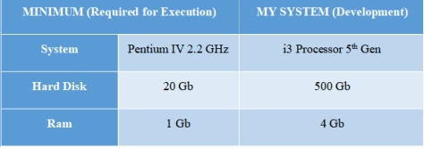
  - Software Requirements / Technologies Used
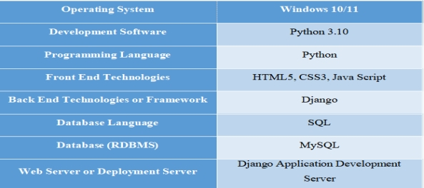
5.System Design
5.1System environment
What is Python :
Below are some facts about Python.
Python is currently the most widely used multi-purpose, high-level programming language.
Python allows programming in Object-Oriented and Procedural paradigms. Python programs generally are smaller than other programming languages like Java.
Programmers have to type relatively less and indentation requirement of the language, makes them readable all the time.
Python language is being used by almost all tech-giant companies like – Google, Amazon, Facebook, Instagram, Dropbox, Uber… etc.
The biggest strength of Python is huge collection of standard library which can be used for the following –

- Machine Learning
- GUI Applications (like Kivy, Tkinter, PyQt etc. )
- Web frameworks like Django (used by YouTube, Instagram, Dropbox)
- Image processing (like Opencv, Pillow)
- Web scraping (like Scrapy, BeautifulSoup, Selenium)
- Test frameworks
- Multimedia
What is Machine Learning : -
Before we take a look at the details of various machine learning methods, let's start by looking at what machine learning is, and what it isn't. Machine learning is often categorized as a subfield of artificial intelligence, but I find that categorization can often be misleading at first brush. The study of machine learning certainly arose from research in this context, but in the data science application of machine learning methods, it's more helpful to think of machine learning as a means of building models of data.
Fundamentally, machine learning involves building mathematical models to help understand data. "Learning" enters the fray when we give these models tunable parameters that can be adapted to observed data; in this way the program can be considered to be "learning" from the data. Once these models have been fit to previously seen data, they can be used to predict and understand aspects of newly observed data. I'll leave to the reader the more philosophical digression regarding the extent 28
to which this type of mathematical, model-based "learning" is similar to the "learning" exhibited by the human brain.Understanding the problem setting in machine learning is essential to using these tools effectively, and so we will start with some broad categorizations of the types of approaches we'll discuss here.
Types of Machine Learning
- Supervised Learning – This involves learning from a training dataset with labeled data using classification and regression models. This learning process continues until the required level of performance is achieved.
- Unsupervised Learning – This involves using unlabelled data and then finding the underlying structure in the data in order to learn more and more about the data itself using factor and cluster analysis models.
- Semi-supervised Learning – This involves using unlabelled data like Unsupervised Learning with a small amount of labeled data. Using labeled data vastly increases the learning accuracy and is also more cost-effective than Supervised Learning.
Reinforcement Learning – This involves learning optimal actions through trial and error. So the next action is decided by learning behaviors that are based on the current state and that will maximize the reward in the future.
Python
Python is an interpreted high-level programming language for general-purpose programming. Created by Guido van Rossum and first released in 1991, Python has a design philosophy that emphasizes code readability, notably using significant whitespace.
Python features a dynamic type system and automatic memory management. It supports multiple programming paradigms, including object-oriented, imperative, functional and procedural, and has a large and comprehensive standard library.
• Python is Interpreted − Python is processed at runtime by the interpreter. You do not need to compile your program before executing it. This is similar to PERL and PHP.
• Python is Interactive − you can actually sit at a Python prompt and interact with the interpreter directly to write your programs.

Python also acknowledges that speed of development is important. Readable and terse code is part of this, and so is access to powerful constructs that avoid tedious repetition of code. Maintainability also ties into this may be an all but useless metric, but it does say something about how much code you have to scan, read and/or understand to troubleshoot problems or tweak behaviors. This speed 36
of development, the ease with which a programmer of other languages can pick up basic Python skills and the huge standard library is key to another area where Python excels. All its tools have been quick to implement, saved a lot of time, and several of them have later been patched and updated by people with no Python background - without breaking.
Modules Used in Project :-
Tensorflow
TensorFlow is a free and open-source software library for dataflow and differentiable programming across a range of tasks. It is a symbolic math library, and is also used for machine learning applications such as neural networks. It is used for both research and production at Google.
TensorFlow was developed by the Google Brain team for internal Google use. It was released under the Apache 2.0 open-source license on November 9, 2015.
Numpy
Numpy is a general-purpose array-processing package. It provides a high-performance multidimensional array object, and tools for working with these arrays.
It is the fundamental package for scientific computing with Python. It contains various features including these important ones:
- A powerful N-dimensional array object
- Sophisticated (broadcasting) functions
- Tools for integrating C/C++ and Fortran code
- Useful linear algebra, Fourier transform, and random number capabilities
Besides its obvious scientific uses, Numpy can also be used as an efficient multi-dimensional container of generic data. Arbitrary data-types can be defined using Numpy which allows Numpy to seamlessly and speedily integrate with a wide variety of databases.
Pandas
Pandas is an open-source Python Library providing high-performance data manipulation and analysis tool using its powerful data structures. Python was majorly used for data munging and preparation. It had very little contribution towards data analysis. Pandas solved this problem. Using Pandas, we can accomplish five typical steps in the processing and analysis of data, regardless of the origin of data load, prepare, manipulate, model, and analyze. Python with Pandas is used in a 37

wide range of fields including academic and commercial domains including finance, economics, Statistics, analytics, etc.
Matplotlib
Matplotlib is a Python 2D plotting library which produces publication quality figures in a variety of hardcopy formats and interactive environments across platforms. Matplotlib can be used in Python scripts, the Python and IPython shells, the Jupyter Notebook, web application servers, and four graphical user interface toolkits. Matplotlib tries to make easy things easy and hard things possible. You can generate plots, histograms, power spectra, bar charts, error charts, scatter plots, etc., with just a few lines of code. For examples, see the sample plots and thumbnail gallery.
For simple plotting the pyplot module provides a MATLAB-like interface, particularly when combined with IPython. For the power user, you have full control of line styles, font properties, axes properties, etc, via an object oriented interface or via a set of functions familiar to MATLAB users.
Scikit – learn
Scikit-learn provides a range of supervised and unsupervised learning algorithms via a consistent interface in Python. It is licensed under a permissive simplified BSD license and is distributed under many Linux distributions, encouraging academic and commercial use. Python
Python is an interpreted high-level programming language for general-purpose programming. Created by Guido van Rossum and first released in 1991, Python has a design philosophy that emphasizes code readability, notably using significant whitespace.
Python features a dynamic type system and automatic memory management. It supports multiple programming paradigms, including object-oriented, imperative, functional and procedural, and has a large and comprehensive standard library.
- Python is Interpreted − Python is processed at runtime by the interpreter. You do not need to compile your program before executing it. This is similar to PERL and PHP.
- Python is Interactive − you can actually sit at a Python prompt and interact with the interpreter directly to write your programs.

Python also acknowledges that speed of development is important. Readable and terse code is part of this, and so is access to powerful constructs that avoid tedious repetition of code. Maintainability also ties into this may be an all but useless metric, but it does say something about how much code you have to scan, read and/or understand to troubleshoot problems or tweak behaviors. This speed of development, the ease with which a programmer of other languages can pick up basic Python 38

skills and the huge standard library is key to another area where Python excels. All its tools have been quick to implement, saved a lot of time, and several of them have later been patched and updated by people with no Python background - without breaking.

5.2 System Components:

1. Facial Emotion Recognition Module:

The Facial Emotion Recognition (FER) Module determines, collects, and assesses users' facial emotion expressions to determine their current emotion. The FER Module utilizes state-of-the-art computer vision and deep learning technologies and processes facial expressions at a granular level, determining subtle movement cues, such as smiles, frowns, raised eyebrows, and eye movements. Emotion will be categorized as happiness, sadness, anger, fear, surprise, and disgust based on these facial cues. FER Module analyzes images of video frames in real-time, meaning emotional information provided to the customer service representative is continuously updated throughout user interaction, with new emotion assessments delivered to the customer agent for additional support. The FER Module is the first step in emotion assessment for customer sentiment and subsequently serves as input for personalized recommendations for the customer service representative.

2. Voice Tone Analysis Module:

The Voice Tone Analysis Module regulates and assesses vocal characteristics such as pitch, tone, volume, and speech rate to interpret the user's mood and engagement level. Signal Processing and machine learning models are developed to describe vocal emotion uttered by a user considering excitement, frustration, and neutrality. Although the FER Module and Voice Tone Analysis Module each independently determine user emotion, together (multimodal) they provide an enhanced interpretation of expressions which increases accuracy and reliability - especially in situations when facial expressions are ambiguous or partially accessible. The Voice Tone Analysis Module engages all situations to improve user detection by introducing voice analysis technology when facial expressions are lost.

3. Customized Suggestions Feature:

The Customized Suggestions Feature utilizes the emotional information captured from the FER and Voice Tone Analysis features, in addition to user behavior and preference information, to provide customized suggestions with context. Using data mining, machine learning, and predictive analytics methods, the feature can determine the most applicable products, services, or content to make suggestions to the user in real-time. Suggestions are updated dynamically based on changes to the user’s emotional state and their interaction history with the suggested product, service, or content, resulting in timely, applicable, and customized suggestions. The feature adds value to user engagement and satisfaction by providing suggestions consistent with their preferences and current emotions.

5.3 Data Flow Diagram:

- The DFD is also called as bubble chart. It is a simple graphical formalism that can be used to represent a system in terms of input data to the system, various processing carried out on this data, and the output data is generated by this system.
- The data flow diagram (DFD) is one of the most important modeling tools. It is used to model the system components. These components are the system process, the data used by the process, an external entity that interacts with the system and the information flows in the system.

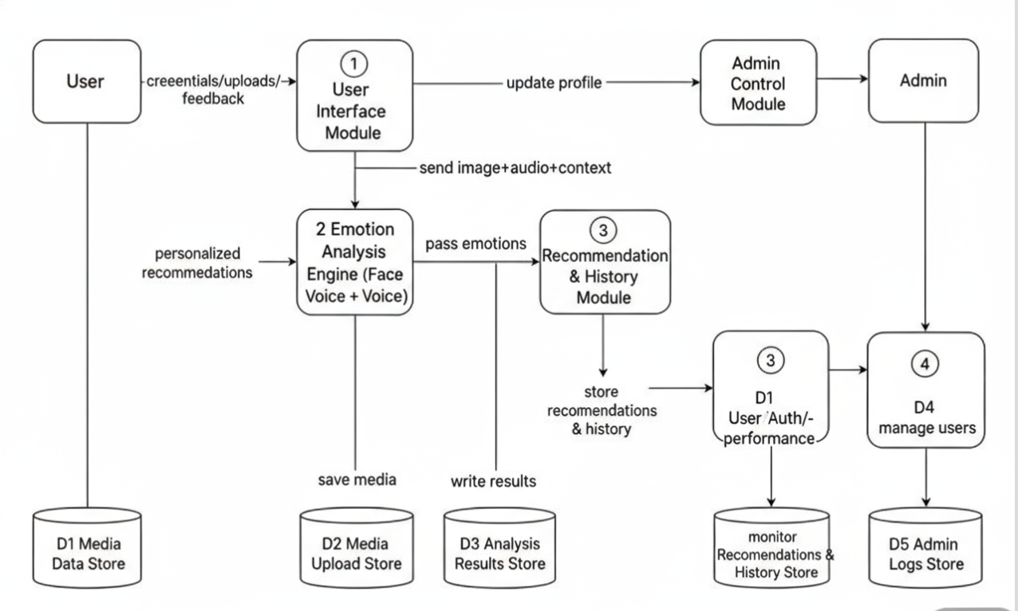

Uml Diagrams
UML stands for Unified Modeling Language. UML is a standardized general-purpose modeling language in the field of object-oriented software engineering. The standard is managed, and was created by, the Object Management Group.
The goal is for UML to become a common language for creating models of object oriented computer software. In its current form UML is comprised of two major components: a Meta-model and a notation. In the future, some form of method or process may also be added to; or associated with, UML.
The Unified Modeling Language is a standard language for specifying, Visualization, Constructing and documenting the artifacts of software system, as well as for business modeling and other non-software systems.
The UML represents a collection of best engineering practices that have proven successful in the modeling of large and complex systems.
The UML is a very important part of developing objects oriented software and the software development process. The UML uses mostly graphical notations to express the design of software projects.

Goals:
The Primary goals in the design of the UML are as follows:
- Provide users a ready-to-use, expressive visual modeling Language so that they can develop and exchange meaningful models.
- Provide extendibility and specialization mechanisms to extend the core concepts.
- Be independent of particular programming languages and development process.
- Provide a formal basis for understanding the modeling language.
- Encourage the growth of OO tools market.
- Support higher level development concepts such as collaborations, frameworks, patterns and components.
- Integrate best practices.

Use Case Diagram:
A use case diagram in the Unified Modeling Language (UML) is a type of behavioral diagram defined by and created from a Use-case analysis. Its purpose is to present a graphical overview of the functionality provided by a system in terms of actors, their goals (represented as use cases), and any dependencies between those use cases. The main purpose of a use case diagram is to show what system functions are performed for which actor. Roles of the actors in the system can be depicted.
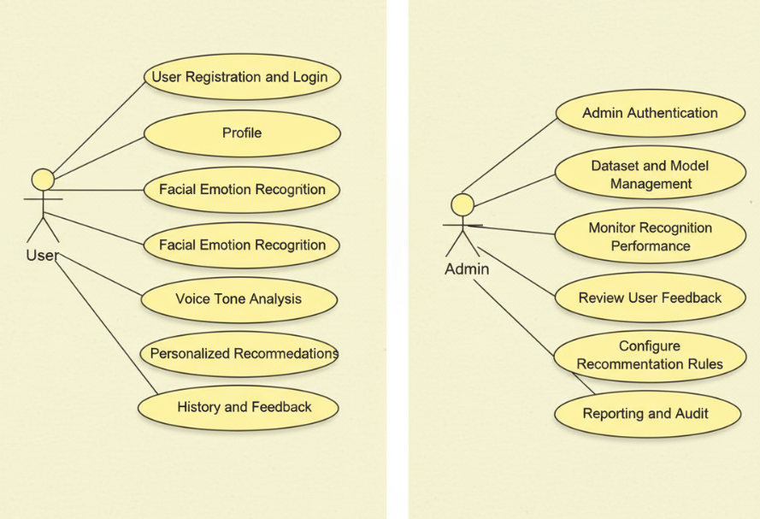

Class Diagram:
In software engineering, a class diagram in the Unified Modeling Language (UML) is a type of static structure diagram that describes the structure of a system by showing the system's classes, their attributes, operations (or methods), and the relationships among the classes. It explains which class contains information.
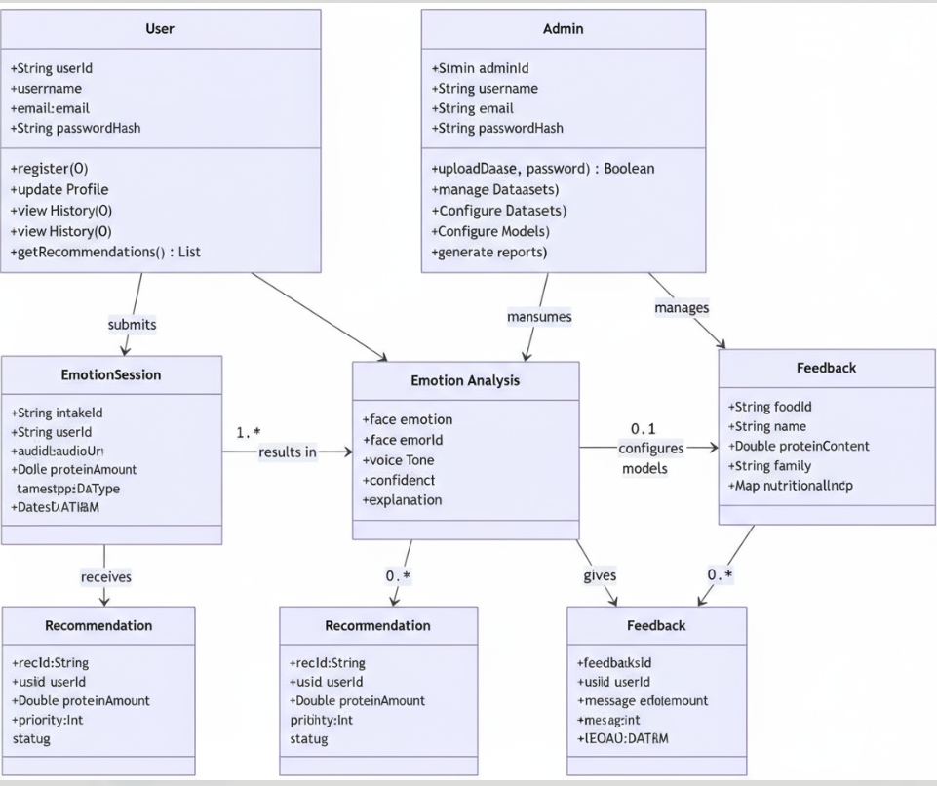
Sequence Diagram:
A sequence diagram in Unified Modeling Language (UML) is a kind of interaction diagram that shows how processes operate with one another and in what order. It is a construct of a Message Sequence Chart. Sequence diagrams are sometimes called event diagrams, event scenarios, and timing diagrams.
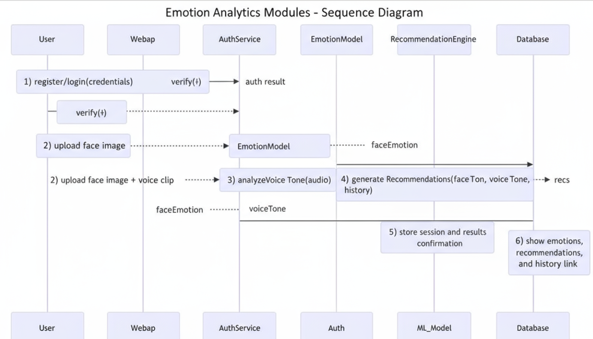
Activity Diagram:
Activity diagrams are graphical representations of workflows of stepwise activities and actions with support for choice, iteration and concurrency. In the Unified Modeling Language, activity diagrams can be used to describe the business and operational step-by-step workflows of components in a system. An activity diagram shows the overall flow of control.
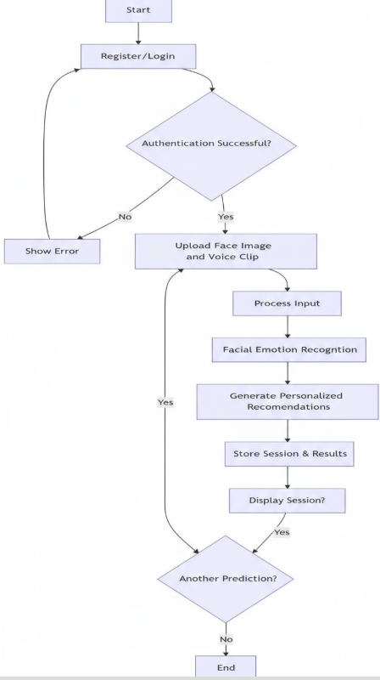

6. Implementation
6.1 Sample code
7. System Testing
7.1 Types of Testing
System Testing
Types of Software Testing: Different Testing Types with Details
We, as testers, are aware of the various types of Software Testing like Functional Testing, Non-Functional Testing, Automation Testing, Agile Testing, and their sub-types, etc.
Each type of testing has its own features, advantages, and disadvantages as well. However, in this tutorial, we have covered mostly each and every type of software testing which we usually use in our day-to-day testing life.
Different Types of Software Testing
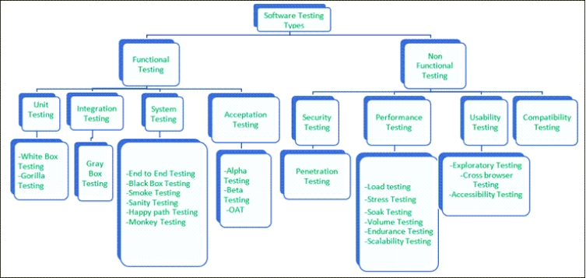

Functional Testing
There are four main types of functional testing.
#1) Unit Testing
Unit testing is a type of software testing which is done on an individual unit or component to test its corrections. Typically, Unit testing is done by the developer at the application development phase. Each unit in unit testing can be viewed as a method, function, procedure, or object. Developers often use test automation tools such as NUnit, Xunit, JUnit for the test execution.
Unit testing is important because we can find more defects at the unit test level.
For example, there is a simple calculator application. The developer can write the unit test to check if the user can enter two numbers and get the correct sum for addition functionality.
a) White Box Testing
White box testing is a test technique in which the internal structure or code of an application is visible and accessible to the tester. In this technique, it is easy to find loopholes in the design of an application or fault in business logic. Statement coverage and decision coverage/branch coverage are examples of white box test techniques.
b) Gorilla Testing
Gorilla testing is a test technique in which the tester and/or developer test the module of the application thoroughly in all aspects. Gorilla testing is done to check how robust your application is.
For example, the tester is testing the pet insurance company’s website, which provides the service of buying an insurance policy, tag for the pet, Lifetime membership. The tester can focus on any one module, let’s say, the insurance policy module, and test it thoroughly with positive and negative test scenarios.
#2) Integration Testing
Integration testing is a type of software testing where two or more modules of an application are logically grouped together and tested as a whole. The focus of this type of testing is to find the defect on interface, communication, and data flow among modules. Top-down or Bottom-up approach is used while integrating modules into the whole system.
This type of testing is done on integrating modules of a system or between systems. For example, a user is buying a flight ticket from any airline website. Users can see flight details and payment information while buying a ticket, but flight details and payment processing are two different systems. Integration testing should be done while integrating of airline website and payment processing system.
a) Gray box testing
As the name suggests, gray box testing is a combination of white-box testing and black-box testing. Testers have partial knowledge of the internal structure or code of an application.
#3) System Testing
System testing is types of testing where tester evaluates the whole system against the specified requirements.
a) End to End Testing
It involves testing a complete application environment in a situation that mimics real-world use, such as interacting with a database, using network communications, or interacting with other hardware, applications, or systems if appropriate.
For example, a tester is testing a pet insurance website. End to End testing involves testing of buying an insurance policy, LPM, tag, adding another pet, updating credit card information on users’ accounts, updating user address information, receiving order confirmation emails and policy documents.
b) Black Box Testing
Blackbox testing is a software testing technique in which testing is performed without knowing the internal structure, design, or code of a system under test. Testers should focus only on the input and output of test objects.
Detailed information about the advantages, disadvantages, and types of Black Box testing can be found here.
c) Smoke Testing
Smoke testing is performed to verify that basic and critical functionality of the system under test is working fine at a very high level.
Whenever a new build is provided by the development team, then the Software Testing team validates the build and ensures that no major issue exists. The testing team will ensure that the build is stable, and a detailed level of testing will be carried out further.
For example, tester is testing pet insurance website. Buying an insurance policy, adding another pet, providing quotes are all basic and critical functionality of the application. Smoke testing for this website verifies that all these functionalities are working fine before doing any in-depth testing.
d) Sanity Testing
Sanity testing is performed on a system to verify that newly added functionality or bug fixes are working fine. Sanity testing is done on stable build. It is a subset of the regression test.
For example, a tester is testing a pet insurance website. There is a change in the discount for buying a policy for second pet. Then sanity testing is only performed on buying insurance policy module.
e) Happy path Testing
The objective of Happy Path Testing is to test an application successfully on a positive flow. It does not look for negative or error conditions. The focus is only on valid and positive inputs through which the application generates the expected output.
f) Monkey Testing
Monkey Testing is carried out by a tester, assuming that if the monkey uses the application, then how random input and values will be entered by the Monkey without any knowledge or understanding of the application.
The objective of Monkey Testing is to check if an application or system gets crashed by providing random input values/data. Monkey Testing is performed randomly, no test cases are scripted, and it is not necessary to be aware
of the full functionality of the system.
#4) Acceptance Testing
Acceptance testing is a type of testing where client/business/customer test the software with real time business scenarios.
The client accepts the software only when all the features and functionalities work as expected. This is the last phase of testing, after which the software goes into production. This is also called User Acceptance Testing (UAT).
a) Alpha Testing
Alpha testing is a type of acceptance testing performed by the team in an organization to find as many defects as possible before releasing software to customers.
For example, the pet insurance website is under UAT. UAT team will run real-time scenarios like buying an insurance policy, buying annual membership, changing the address, ownership transfer of the pet in a same way the user uses the real website. The team can use test credit card information to process payment-related scenarios.
b) Beta Testing
Beta Testing is a type of software testing which is carried out by the clients/customers. It is performed in the Real Environment before releasing the product to the market for the actual end-users.
Beta Testing is carried out to ensure that there are no major failures in the software or product, and it satisfies the business requirements from an end-user perspective. Beta Testing is successful when the customer accepts the software.
Usually, this testing is typically done by the end-users. This is the final testing done before releasing the application for commercial purposes. Usually, the Beta version of the software or product released is limited to a certain number of users in a specific area.
So, the end-user uses the software and shares the feedback with the company. The company then takes necessary action before releasing the software worldwide.
c) Operational acceptance testing (OAT)
Operational acceptance testing of the system is performed by operations or system administration staff in the production environment. The purpose of operational acceptance testing is to make sure that the system administrators can keep the system working properly for the users in a real-time environment.
The focus of the OAT is on the following points:
- Testing of backup and restore.
- Installing, uninstalling, upgrading software.
- The recovery process in case of natural disaster.
- User management.
- Maintenance of the software.

Non-Functional Testing
There are four main types of functional testing.
#1) Security Testing
It is a type of testing performed by a special team. Any hacking method can penetrate the system.
Security Testing is done to check how the software, application, or website is secure from internal and/or external threats. This testing includes how much software is secure from malicious programs, viruses and how secure & strong the authorization and authentication processes are.
It also checks how software behaves for any hacker’s attack & malicious programs and how software is maintained for data security after such a hacker attack.
a) Penetration Testing
Penetration Testing or Pen testing is the type of security testing performed as an authorized cyberattack on the system to find out the weak points of the system in terms of security.
Pen testing is performed by outside contractors, generally known as ethical hackers. That is why it is also known as ethical hacking. Contractors perform different operations like SQL injection, URL manipulation, Privilege Elevation, session expiry, and provide reports to the organization.
Notes: Do not perform the Pen testing on your laptop/computer. Always take written permission to do pen tests.
#2) Performance Testing
Performance testing is testing of an application’s stability and response time by applying load.
The word stability means the ability of the application to withstand in the presence of load. Response time is how quickly an application is available to users. Performance testing is done with the help of tools. Loader.IO, JMeter, LoadRunner, etc. are good tools available in the market.
a) Load testing
Load testing is testing of an application’s stability and response time by applying load, which is equal to or less than the designed number of users for an application.
For example, your application handles 100 users at a time with a response time of 3 seconds, then load testing can be done by applying a load of the maximum of 100 or less than 100 users. The goal is to verify that the application is responding within 3 seconds for all the users.
b) Stress Testing
Stress testing is testing an application’s stability and response time by applying load, which is more than the designed number of users for an application.
For example, your application handles 1000 users at a time with a response time of 4 seconds, then stress testing can be done by applying a load of more than 1000 users. Test the application with 1100,1200,1300 users and notice the response time. The goal is to verify the stability of an application under stress.
c) Scalability Testing
Scalability testing is testing an application’s stability and response time by applying load, which is more than the designed number of users for an application.
For example, your application handles 1000 users at a time with a response time of 2 seconds, then scalability testing can be done by applying a load of more than 1000 users and gradually increasing the number of users to find out where exactly my application is crashing.
Let’s say my application is giving response time as follows:
- 1000 users -2 sec
- 1400 users -2 sec
- 4000 users -3 sec
- 5000 users -45 sec
- 5150 users- crash – This is the point that needs to identify in scalability testing
d) Volume testing (flood testing)
Volume testing is testing an application’s stability and response time by transferring a large volume of data to the database. Basically, it tests the capacity of the database to handle the data.
e) Endurance Testing (Soak Testing)
Endurance testing is testing an application’s stability and response time by applying load continuously for a longer period to verify that the application is working fine.
For example, car companies soak testing to verify that users can drive cars continuously for hours without any problem.
#3) Usability Testing
Usability testing is testing an application from the user’s perspective to check the look and feel and user-friendliness.
For example, there is a mobile app for stock trading, and a tester is performing usability testing. Testers can check the scenario like if the mobile app is easy to operate with one hand or not, scroll bar should be vertical, background colour of the app should be black and price of and stock is displayed in red or green colour.
The main idea of usability testing of this kind of app is that as soon as the user opens the app, the user should get a glance at the market.
a) Exploratory testing
Exploratory Testing is informal testing performed by the testing team. The objective of this testing is to explore the application and look for defects that exist in the application. Testers use the knowledge of the business domain to test the application. Test charters are used to guide the exploratory testing.
b) Cross browser testing
Cross browser testing is testing an application on different browsers, operating systems, mobile devices to see look and feel and performance.
Why do we need cross-browser testing? The answer is different users use different operating systems, different browsers, and different mobile devices. The goal of the company is to get a good user experience regardless of those devices.
Browser stack provides all the versions of all the browsers and all mobile devices to test the application. For learning purposes, it is good to take the free trial given by browser stack for a few days.
c) Accessibility Testing
The aim of Accessibility Testing is to determine whether the software or application is accessible for disabled people or not.
Here, disability means deafness, colour blindness, mentally disabled, blind, old age, and other disabled groups. Various checks are performed, such as font size for visually disabled, colour and contrast for colour blindness, etc.
#4) Compatibility testing
This is a testing type in which it validates how software behaves and runs in a different environment, web servers, hardware, and network environment.

7.2 Test Cases
Test Case ID | Test Case Description | Expected Result
1 | User Registration & Login | Account created successfully; user can log in securely
2 | Profile Management | Profile changes saved and reflected correctly
3 | Facial Emotion Recognition | System correctly detects and stores emotions (happy, sad, angry, etc.)
4 | Voice Tone Analysis | System analyzes voice pitch, tone, sentiment accurately
5 | Personalized Recommendations | Recommendations displayed correctly based on emotional and behavioral data
6 | History and Feedback | Interaction history displayed; feedback submitted successfully
7 | Admin Login & Authentication | Admin login successful; access rights verified
8 | User Management | Changes applied successfully; user statistics updated
9 | Emotion Data Monitoring | Accurate visualization of facial and voice emotion trends
10 | Recommendation Management & Analytics | Recommendations updated; dashboards and reports generated accurately

  - Discussion of Results (Screen Shorts)

8.Conclusion and Future Enhancements

8.1 Conclusion

The AI-enabled customer analytics system proposed here showcases the potential of leveraging emotion intelligence and data to provide personalized recommendations. With multiple modules - Facial Emotion Recognition, Voice Tone Analysis, and Personalized Recommendation - this system offers a multimodal perception of user emotions in real-time, allowing for highly relevant and empathetic suggestions. One of the main differences between this system and most historical demographic and behavior-based recommendation systems is the incorporation of multimodal visual and auditory emotional expressions, which can help personalize recommendations in real time based on both mood and preference.

The integration of this system has potential applications for increasing customer engagement, satisfaction, and loyalty as businesses can use this information reactively to respond to user needs proactively. It illustrates the role of AI and machine learning in analyzing human emotion and behavior complexities, setting the stage for an even more intelligent, reactive, and user-centric framework. In summary, this research conveys the relevance of utilizing emotion-aware technology for future personalized customer experiences and provides an actionable platform for organizations to develop improved decision making, marketing efforts, and overall quality of interactions.
8.2 Future Enhancements:

The outlined AI-powered customer analytics system exhibits a promising solution to emotion-sensitive personalization through integrating facial and vocal emotion detection with data-driven suggestions. Future developments might involve broadening the scope of data sources to incorporate physiological signals, including heart rate, eye-tracking, or gesture analysis, to pick up on more subtle emotional and engagement patterns. This multimodal integration would enhance the accuracy and sensitivity of emotion detection, particularly for dynamic or real-world customer interactions.

Another important improvement is the inclusion of sophisticated deep learning models, like transformer-based multimodal models, which have the ability to learn nuanced interdependencies among facial expressions, voice cues, and contextual behavioral data. This would enable the system to make even more accurate and contextual recommendations, enhancing both customer satisfaction and business results.

The platform can also be enhanced with real-time adaptive learning, allowing it to personalize engagements constantly from changing customer behavior and feedback. Also, using explainable AI (XAI) methods would give transparency on how the recommendations are made, which promotes customer trust and regulatory compliance.

Integration with broader enterprise systems, including CRM solutions, loyalty initiatives, and omnichannel analytics, may enable smooth personalization across touchpoints, ensuring a harmonious and integrated customer experience. Lastly, privacy-preserving techniques like federated learning and differential privacy may safeguard highly sensitive customer information while still facilitating advanced predictive modeling. The overall system would be more resilient, responsive, and able to provide extremely empathetic and user-focused customer interaction solutions.
9.References

[1] S. Abakarim. "Decision transformer enhanced with emotion and sentiment for personalized recommendation." Scientific Reports 15, no 1 (2025): 6386.
[2] T. Xiu. "The Analysis of emotion aware personalized recommendation system based on IoT data and multimodal emotion fusion." ScienceDirect (2025).
[3] L. Zhao. "Music recommendation system driven by emotion based on multimodal emotion fusion." ScienceDirect (2025).
[4] P. Pichappan. "A Review of the Emotion Induced Music Recommendation Systems." Journal of Digital Information Management 23, no 2 (2025): 112–118.
[5] G. V. L. Narayana. "Mood Based Music Recommendation Using Voice Analysis." International Journal of Scientific & Advanced Technology 5, no 2 (2025): 4162–4167.

[6] H. Kim, "Emotion-oriented recommender system for personalized control of indoor environmental quality," ScienceDirect, 2024.
[7] S. Doshi, "Song recommendation based on voice tone analysis," Journal of Engineering Science and Technology Review, vol. 15, no. 2, pp. 25–30, 2024.
[8] H. Won, "Image recommendation system based on environmental context and emotion recognition," NCBI PubMed Central, 2023.
[9] J. Li, "A comparison of personalized and generalized approaches to emotion recognition using consumer wearable devices: Machine learning study," arXiv preprint arXiv:2308.14245, 2023.
[10] M. Togami & M. Goodwin, "How Amazon Chime SDK's voice tone analysis works," Amazon Science Blog, 2023.

